Kirklin’s Playtime LLC. Discipline and Behavior Management Policy

Date Adopted ________________

Praise and positive reinforcement are effective methods of the behavior management of children. When children receive positive, non-violent, and understanding interactions from adults and others, they develop good self-concepts, problem solving abilities, and self-discipline. Based on this belief of how children learn and develop values, this facility will practice the following discipline and behavior management policy:

We:
- DO praise, reward, and encourage the children.
- DO reason with and set limits for the children.
- DO model appropriate behavior for the children.
- DO modify the classroom environment to attempt to prevent problems before they occur.
- DO listen to the children.
- DO provide alternatives for inappropriate behavior to the children. 7. DO provide the children with natural and logical consequences of their behaviors.
- DO treat the children as people and respect their needs, desires, and feelings.
- DO ignore minor misbehaviors.
10.DO explain things to children on their levels.
11.DO use short supervised periods of time-out sparingly.
12.DO stay consistent in our behavior management program.
13.DO use effective guidance and behavior management techniques that focus on a child’s development.

We:
1. DO NOT spank, shake, bite, pinch, push, pull, slap, or otherwise physically punish the children. 2. DO NOT make fun of, yell at, threaten, make sarcastic remarks about, use profanity, or otherwise verbally abuse the children.
- DO NOT shame or punish the children when bathroom accidents occur.
- DO NOT deny food or rest as punishment.
- DO NOT relate discipline to eating, resting, or sleeping.
- DO NOT leave the children alone, unattended, or without supervision.
- DO NOT place the children in locked rooms, closets, or boxes as punishment.
- DO NOT allow discipline of children by children.
- DO NOT criticize, make fun of, or otherwise belittle children’s parents, families, or ethnic groups.

I, the undersigned parent or guardian of _______________________________
(child's full name), do hereby state that I have read and received a copy of the facility's Discipline and Behavior Management Policy and that the facility's director/operator (or other designated staff member) has discussed the facility's Discipline and Behavior Management Policy with me.

Date of Child's Enrollment: __________________________________________

Signature of Parent or Guardian _______________________________________ Date ____________________
Distribution: one copy to parent(s) signed copy in child's facility record
Revised 8.09
SAMPLE #1 2
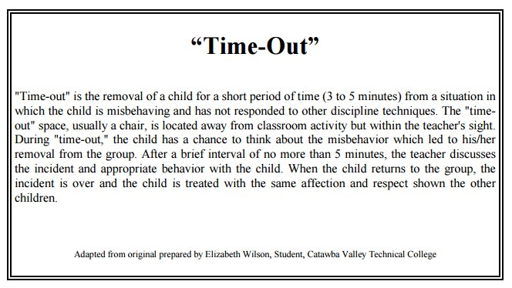
Revised 8.09

